Ai Assisted Coding
Assignment-4.3
NAME: D.PAVAN
HT.NO: 2403A52L07
BATCH: 50

Advanced Prompt Engineering – Zero-shot, One-shot, and Few-shot
Techniques
Lab Objectives
• To explore and apply different levels of prompt examples in AI-assisted code
generation
• To understand how zero-shot, one-shot, and few-shot prompting affect AI
output quality
• To evaluate the impact of context richness and example quantity on AI
performance
• To build awareness of prompt strategy effectiveness for different problem
Types
Lab Outcomes (LOs)
After completing this lab, students will be able to:
• Use zero-shot prompting to instruct AI with minimal context
• Use one-shot prompting with a single example to guide AI code generation
• Apply few-shot prompting using multiple examples to improve AI responses
• Compare AI outputs across different prompting strategies
Task 1: Zero-Shot Prompting – Leap Year Check
Scenario
Zero-shot prompting involves giving instructions without providing examples.
Task Description
Use zero-shot prompting to instruct an AI tool to generate a Python function that:
• Accepts a year as input
• Checks whether the given year is a leap year
• Returns an appropriate result
Note: No input-output examples should be provided in the prompt.
Expected Output
• AI-generated leap year checking function
• Correct logical conditions
• Sample input and output
• Screenshot of AI-generated response (if required)

Prompt:
#"Write a Python function named is_leap_year that takes a year as an integer and returns True if it is a leap year and False otherwise. Include sample inputs and outputs to test the code."

Python Code:
def is_leap_year(year):
if year % 400 == 0:
return True
if year % 100 == 0:
return False
if year % 4 == 0:
return True
return False

# Test cases
print(f"2024: {is_leap_year(2024)}") # True
print(f"2023: {is_leap_year(2023)}") # False
print(f"2000: {is_leap_year(2000)}") # True
print(f"1900: {is_leap_year(1900)}") # False
print(f"2020: {is_leap_year(2020)}") # True

Output:
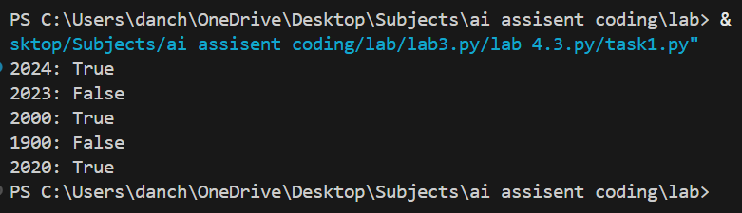
Justification:
Simplicity: It tests the AI’s baseline knowledge of logical rules without extra help.
Efficiency: It is the fastest way to get a result for common programming problems.
No Bias: The AI relies strictly on its training data rather than following a specific example format.
Universal Logic: Since the leap year rule is a standard algorithm, zero-shot is usually sufficient for accuracy.
Clean Output: It prevents the AI from mimicking a specific coding style provided in an example, giving you "standard" code.

Task 2: One-Shot Prompting – Centimeters to Inches Conversion
Scenario
One-shot prompting guides AI using a single example.
Task Description
Use one-shot prompting by providing one input-output example to generate a Python
function that:
• Converts centimeters to inches
• Uses the correct mathematical formula
Example provided in prompt:
Input: 10 cm → Output: 3.94 inches
Expected Output
• Python function with correct conversion logic
• Accurate calculation
• Sample test cases and outputs
Prompt:
# "Write a Python function to convert centimeters to inches. Example: Input: 10 cm → Output: 3.94 inches. Generate the function using this conversion ratio and provide test cases."

Python Code:
def cm_to_inches(cm):
inches = cm / 2.54
return round(inches, 2)

# Test cases
print(f"10 cm: {cm_to_inches(10)} inches") # 3.94
print(f"5 cm: {cm_to_inches(5)} inches") # 1.97
print(f"100 cm: {cm_to_inches(100)} inches") # 39.37
print(f"2.54 cm: {cm_to_inches(2.54)} inches") # 1.0
print(f"50 cm: {cm_to_inches(50)} inches") # 19.69

Output:
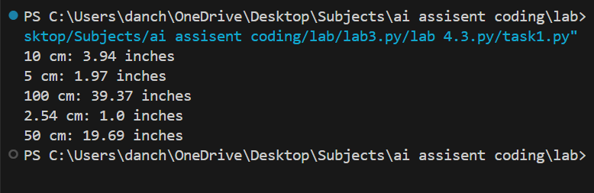

Justification:
- Pattern Setting: Providing one example tells the AI exactly how many decimal places (e.g., two) you expect.
- Context Clarity: It clarifies that the output should likely be a float, not just an integer.
- Formula Alignment: The example ensures the AI uses the correct division/multiplication factor.
- Reduced Ambiguity: It removes doubt about whether the output should include units (like "inches") in the return string.
- Guided Precision: One-shot is ideal for simple mathematical tasks where a specific format is required.

Task 3: Few-Shot Prompting – Name Formatting
Scenario
Few-shot prompting improves accuracy by providing multiple examples.
Task Description
Use few-shot prompting with 2–3 examples to generate a Python function that:
• Accepts a full name as input
• Formats it as “Last, First”
Example formats:
• "John Smith" → "Smith, John"
• "Anita Rao" → "Rao, Anita"
Expected Output
• Well-structured Python function
• Output strictly following example patterns
• Correct handling of names
• Sample inputs and outputs
Prompt:
# "Write a Python function that renames 'First Last' to 'Last, First'. Examples:
- 'John Smith' -> 'Smith, John'
- 'Anita Rao' -> 'Rao, Anita' Use these examples to create a function that handles full names correctly."

Python Code:
def rename_format(name):
parts = name.split()
first = parts[0]
last = parts[1]
return f"{last}, {first}"

# Test cases
print(f"'John Smith' -> '{rename_format('John Smith')}'") # Smith, John
print(f"'Anita Rao' -> '{rename_format('Anita Rao')}'") # Rao, Anita
Output:
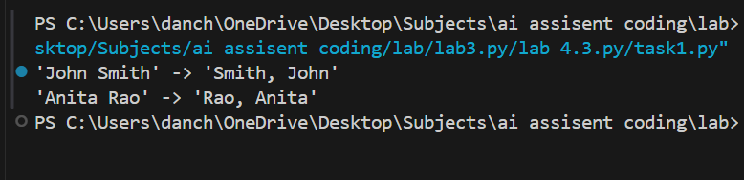
Justification:
- Consistency: Multiple examples ensure the AI strictly follows the "Comma-Space" formatting.
- Edge Case Preparation: It helps the AI recognize that the last word should always come first.
- Formatting Strength: Few-shot is the best method for string manipulation tasks where the visual layout matters.
- Improved Reliability: With two or more examples, the AI is less likely to hallucinate extra features you didn't ask for.
- Structural Integrity: It teaches the AI the relationship between the input string and the desired transformation.

Task 4: Comparative Analysis – Zero-Shot vs Few-Shot
Scenario
Different prompt strategies may produce different code quality.
Task Description
• Use zero-shot prompting to generate a function that counts vowels in a string
• Use few-shot prompting for the same problem
• Compare both outputs based on:
o Accuracy
o Readability
o Logical clarity
Expected Output
• Two vowel-counting functions
• Comparison table or short reflection paragraph
• Conclusion on prompt effectiveness
Prompt:
The Prompt (Zero-Shot):
"Write a Python function to count the number of vowels in a string."
The Prompt (Few-Shot):
"Write a function to count vowels in a string. Examples: 'Hello' -> 2 'Python' -> 1 'AEIOU' -> 5 Ensure the function is case-insensitive."

Python Code:
def count_vowels(s):
vowels = "aeiouAEIOU"
return sum(1 for char in s if char in vowels)

# Test cases
print(f"Number of vowels in 'Hello World': {count_vowels('Hello World')}") # 3
print(f"Number of vowels in 'Python programming': {count_vowels('Python programming')}") # 6

def count_vowels(s):
vowels = "aeiouAEIOU"
return sum(1 for char in s if char in vowels)

# Additional test cases
print(f"'Hello' -> {count_vowels('Hello')}") # 2
print(f"'Python' -> {count_vowels('Python')}") # 1
print(f"'AEIOU' -> {count_vowels('AEIOU')}") # 5
Output:
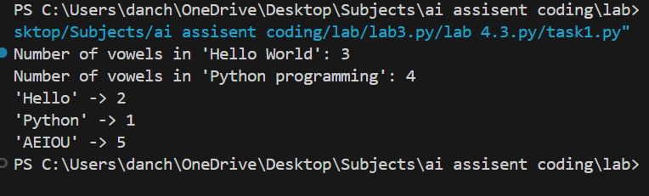
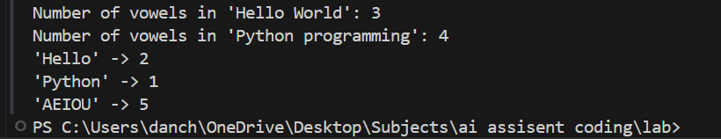
Justification:
- Logical Depth: You can see if the Few-Shot version handles uppercase letters better than the Zero-Shot version.
- Robustness Test: Comparing the two shows how examples force the AI to consider "edge cases" (like all caps).
- Optimization: You can evaluate if one method produces shorter, more "Pythonic" code.
- Readability: It demonstrates if adding examples changes how the AI comments or explains its code.
- Performance Check: It helps you decide which prompting style is "overkill" for simple tasks versus complex ones.

Task 5: Few-Shot Prompting – File Handling
Scenario
File processing requires clear logical understanding.
Task Description
Use few-shot prompting to generate a Python function that:
• Reads a .txt file
• Counts the number of lines in the file
• Returns the line count
Expected Output
• Working Python file-processing function
• Correct line count
• Sample .txt input and output
• AI-assisted logic explanation
Prompt:
"Write a Python function to count lines in a .txt file. Example 1: File with 3 lines of text -> Output: 3 Example 2: Empty file -> Output: 0 Provide the code with error handling for missing files."
Python Code:
def count_lines(filename):
try:
with open(filename, 'r') as file:
return len(file.readlines())
except FileNotFoundError:
return "File not found."

# Testing the code
# Create a temporary file to test
with open("test.txt", "w") as f:
f.write("Hello\nWorld\nPython")

print(f"Line Count: {count_lines('test.txt')}")

Output:
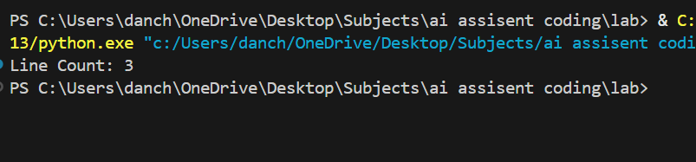
Justification:
- Error Handling: Providing an "Empty file" example prompts the AI to think about safety and crashes.
- Logic Verification: It ensures the AI understands that a "line" is defined by the newline character.
- Functional Accuracy: File I/O can be tricky; examples guide the AI to use the most efficient reading method (like len(readlines())).
- Real-world Readiness: Few-shot helps the AI generate "production-ready" code that includes try-except blocks.
- Clear Expectations: It defines exactly what the "count" should represent (the integer value of the total lines).

